Karthick J (DO14)

Question:

Create the K8s EKS,further you have to do the deployment of Nginx application.

Solution:

Step :1

Installing K8s in instance.

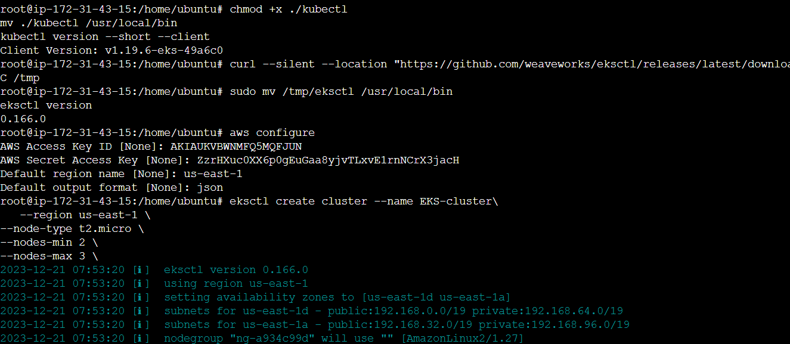

Step:2

Cluster creation after installing cluster in CLI.

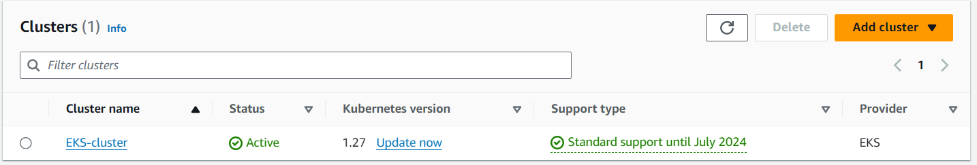

Step:3

Code for Ngnix deployment.

Deployment Code:

apiVersion: apps/v1

kind: Deployment

metadata:

  name: eks-deployment

spec:

  replicas: 2

  selector:

    matchLabels:

      app: myapp

  template:

    metadata:

      labels:

        app: myapp

    spec:

      containers:

      - name: myapp

        image: nginx

        ports:

        - containerPort: 80

---

apiVersion: v1

kind: Service

metadata:

  name: eks-service

spec:

  type: NodePort

  selector:

    app: myapp

  ports:

  - port: 80

    targetPort: 80

Step:4

Applying the deployment.

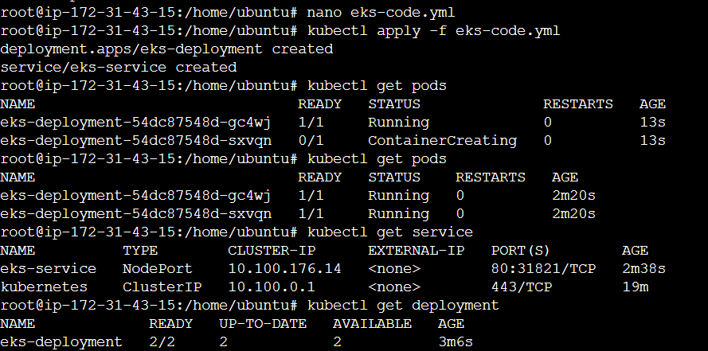

Step: 5

Output.

Node-1 output:

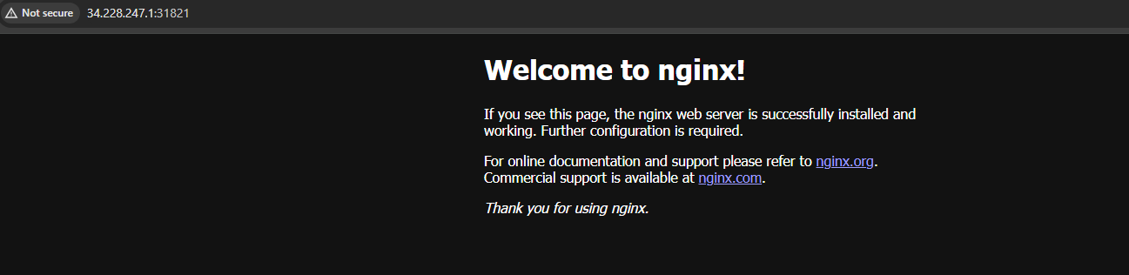

Node-2 output:

